**Table of Contents**

|  |  |  |
| --- | --- | --- |
| **Sr. No.** | **Title** | **Page No.** |
|  |  |  |
| 1 | Introduction: | 5 |
|  | 1. Purpose | 5 |
|  | 1. Overview | 5 |
|  | 1. Scope | 5 |
| 2 | Overall Description: | 6 |
|  | 1. Productive Perspective | 6 |
|  | 1. Operative Environment | 6 |
| 3 | Functional Requirements | 6 |
| 4 | Time Taken | 7 |
| 5 | Non-Functional Requirements: | 7 |
|  | 1. Performance Requirements | 7 |
|  | 1. Security Requirements | 7 |
|  | 1. Analysis Quality Attributes | 7 |
| 6 | Design Phase: | 7 |
|  | 1. DFD (Data Flow Diagram) | 8-11 |
|  | 1. Flow Chart | 11 |
| 7 | Bibliography/ References: | 11 |
|  |  |  |

Introduction:

* 1. Purpose:

This document provides the requirement specifications for **Mobile Phone Comparison** and Visualizingthe Mobile phone prediction Data. It specifies user interface attributes, functional and nonfunctional requirements, and long-term ideas for the evolution of the system.

* 1. Overview:

It’s a data science analysis project in which analysis done in python with the help of CSV Dataset, matplotlib, numpy, pandas and seaborn. In which,

1. I extracted the data from Dataset downloaded from the Google website Kaggle.
2. Removing redundancy and checking of the missing values.
3. Extracting the insights on a different insights.
4. Visualizing the insights in a different ways using matplotlib and seaborn
5. Extracted the data according to the different aspects.
   1. Scope:

**----**🡪 **Best Selling Smartphone Analysis.** 🡨**----**

* This kind of prediction will help companies estimate price of mobiles to give tough competition to other mobile manufacturer
* Also it will be useful for Consumers to verify that they are paying best price for a mobile.

Our analysis of the dataset will be based on a set of research questions. All data manipulation will be done before answering each research question in the corresponding code chunk.

2. Overall Description

2.1 Analysis Objective:

## This project provides an interactive visualization platform of the mobile phones comparison analysis, to better support the researchers with deeper understandings of the patterns and regularities of the current world competition of the smartphone market. This system seeks and presents potential correlations, clustering performances and feature rankings of different companies and parties, associated with types of specifications and aspects of the smartphone.

2.2 Operating Environment:

Mobile phone analysis can be done by other ide too, So, I choose to do it on a documented type format ide named jupyter. Which come separately as well as with the famous package of anaconda.

For Analysis, we require:

1. You can use dataset for analysis if you like which is available on Kaggle.
2. Needed an IDE such as Jupyter.
3. Seaborn for Visualization
4. Pandas for data Analysis.
5. To Run the Jupyter:
6. Ram: 512MB
7. Space: 2GB
8. Core: Dual Core
9. Cache: 512kb

3. Function Requirements

* Proper formatted csv file dataset.
* A device with the jupyter ide.
* Matplotlib package installed.
* Seaborn package installed.
* Pandas package installed.
* Numpy package installed.

4. Time Taken:

|  |  |  |
| --- | --- | --- |
| 1. | Extracting Dataset, Renaming and Removing redundancy | 2 Days |
| 2. | Design Phase | 5 Days |
| 3. | Data Analysis on Different aspects | 7 Days |
| 4. | Extracting the insights of a particular Country | 6 Days |

5. Non-Functional Requirements

5.1. Performance Requirements:

* The user must have a device which is at least have the specification and space to store and run dataset on Jupyter.
* The user must have at least of 500kbps of net connection in order to download the data from the different sources without much delay.

5.2 Security Requirements:

* Data Must be cleaned and Nearly Accurate for better insights.
* Dataset should not be shared with anyone.

5.3 Analysis Quality Attributes:

* AVAILABILITY: The dataset should be clear and should be downloaded from a trusted source.
* MAINTAINABILITY: Use of recently updated dataset can give us better insights.
* USABILITY: The analysis can be done anywhere without the connectivity of internet and a device.

6. Design Phase:

Design phase deals with transforming there requirements, as described in the SRS document into a form that can be used while programming. In design phase of SDLC based on requirement captured in SRS.

6.1 DFD (DataFlow Diagram)

A data flow diagram (DFD) maps out the flow of information for any processor system.

Level 0

Data

Source

Analysis

result

Data

Data Extracted

Level 1

Level 2

Data Extracted

Result Extracted

Analysis and Visualization done

1. Max and Min No. of Phone Sold by a company.

Including Cleaned Dataset

1. Company Model Min and Max Unit

Visualization

Including Cleaned Dataset

1. Top 10 Most Sold Phones and Visualization

Data

Visualization

Including Cleaned Dataset

1. Top Manufacturers

Including Cleaned Dataset

Extracting Data

1. Least 10 phones that are sold

Visualization

Extracting Data

Including Cleaned Dataset

1. Best selling Phones & Manufacturer

Visualization

Including Cleaned Dataset

1. Best Selling phones in 2020

Visualization

Including Cleaned Dataset

1. Phones Sold in millions

Including Cleaned Dataset

Data

Visualization

6.2 Flow Chart:

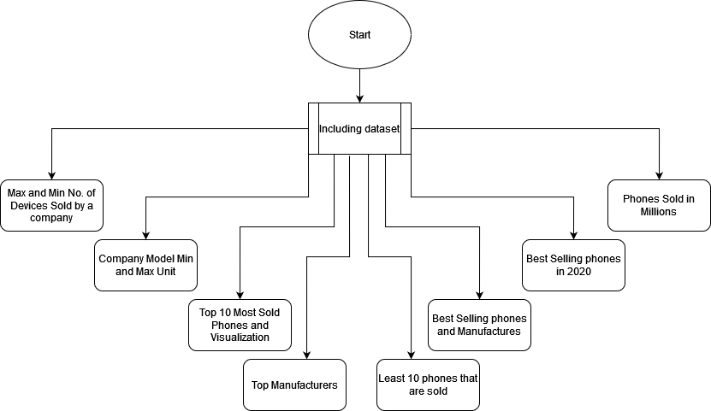

7. References:

* <https://www.youtube.com/>
* [Research Paper about Cell Phones | UsefulResearchPapers.com](https://usefulresearchpapers.com/research-paper-about-cell-phones/)
* <https://www.kaggle.com/>
* <https://www.google.com/>